How to PAY Your Taxes Online

- Go to http://www.ashfordtownhall.org/ and click the button in the footer of the page or click the link at the top of the page.

- In the search bar enter your last name, space, and first initial.
Ex. Name: John Smith
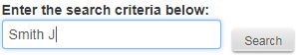

- If there is a shopping cart under the pay section, then there is an outstanding balance.
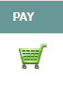
Click that button to add as many bills to your cart as you want

- Find which bill you want to pay
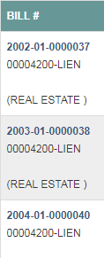
Ex.
2002-01-37
- 2002 is the Grand List
2002-01-37
- 01 is Real Estate
  - 02 Is Personal Property
  - 03 is Motor Vehicle
  - 04 is Motor Vehicle Supplement
2002-01-37
- 37 is the bill number

- You MUST pay the OLDEST bills FIRST
  - Oldest Grand List

- When all of the bills are in your shopping cart
Click and Check Out

- Read the Terms and Conditions before you press
- Especially if You Have Past Due Taxes

- Make sure the next cart is the same as the previous one and choose how you would like to pay. Then press
- Treat All Debit Cards As Credit Cards

- Enter Payment information, Review, and Submit.
- There is a 2.95% fee for Credit and Debit Cards
- There is a $1.95 fee for Checking Account

